# 7X EV3 Rover programming

Building the basic rover: [see this file](https://le-www-live-s.legocdn.com/sc/media/lessons/mindstorms-ev3/building-instructions/ev3-rem-driving-base-79bebfc16bd491186ea9c9069842155e.pdf)

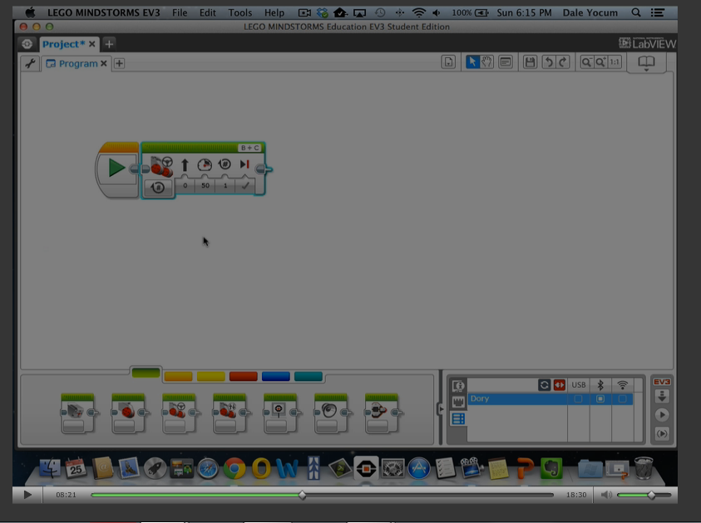

Programming the rover: LEGO Mindstorms EV3 software.

**Useful links you need can be found on the hockerillct website.**

# <https://www.hockerillct.com/16/CT/year7/>

# Record of achievement

**record your progressed here.**

|  |  |  |  |
| --- | --- | --- | --- |
| **Record of achievement:**  **LEGO EV3 Rover programming** | **Program name** | **program explanation and screen print of program** | **task achieved?** |
| Task 1: Build the basic build robot and program it move in a straight line and stop. |  |  |  |
| Task 2: move in a straight line for 50cm then reverse to base starting position |  |  |  |
| Task 3: move in a square around a chair.  a) using repeat commands |  |  |  |
| b) using Loop commands / program |  |  |  |
| Task 4: Attach the ultrasound distance sensor to the rover. [ev3-ultrasonic-sensor-driving-base.pdf](https://education.lego.com/v3/assets/blt293eea581807678a/blte04fb7bf4f716f3d/5f8801e3bf5ab07ee90076c9/ev3-ultrasonic-sensor-driving-base.pdf) |  |  |  |
| Task 5: program your robot so that if an object is placed in front of the robot it moves back. Wait block followed by backwards movement block. |  |  |  |
| Task 6: move in straight line until an object is detected.  <https://www.youtube.com/watch?v=wmwfiPomPGk>  (start at 3 minutes) |  |  |  |
| Task 7: move in straight line until an object is detected and then turn |  |  |  |
| Task 8: Using a loop program the robot to move continuously around the room without driving into objects. |  |  |  |
| Extension: Your choice of task. Try attaching another sensor and the small motor and use them in some way. |  |  |  |